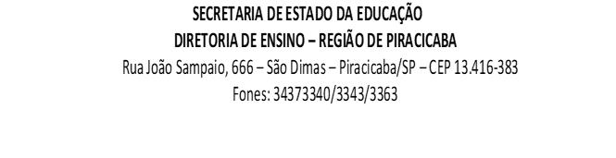

PORTFÓLIO SEMANAL – PROFESSOR SALA DE RECURSO

ESCOLA: ______________________________________________________________________________
ALUNO(A): _____________________________________________________________________________
SÉRIE/ANO:________________
PROFESSOR(A) AEE: ___________________________________________________________________
TURMA AEE: _________________________
PERÍODO: _________________________

OBJETIVOS:
*Expectativas de aprendizagem
*Quais objetivos o(a) aluno(a) deve alcançar?
*Quais habilidades/competências o(a) aluno(a) precisa desenvolver?
____________________________________________________________________________________________________________________________________________________________________________________________
______________________________________________________________________________________________

ATIVIDADES E RECURSOS PROPOSTOS:
*Temas das atividades.
*Recursos a serem utilizados
____________________________________________________________________________________________________________________________________________________________________________________________
______________________________________________________________________________________________

FORMA DE COMUNICAÇÃO COM A FAMÍLIA/ ALUNO(A):
____________________________________________________________________________________________________________________________________________________________________________________________
______________________________________________________________________________________________

DEVOLUTIVA DO ALUNO
*Forma de acompanhamento e supervisão do trabalho ______________________________________________________________________________________________
______________________________________________________________________________________________
______________________________________________________________________________________________

RESULTADOS E ENCAMINHAMENTOS
______________________________________________________________________________________________
______________________________________________________________________________________________
______________________________________________________________________________________________

OBS:
__________________________________________________________________________________________________________________________________________________________________________________________________________________________________________________________________________________________

 | DATA | AÇÃO
__/__/2020
(semanal)
Agenda:

Registre aqui questões relevantes (se houver necessidade):
_____________________________________________________________________________________________________________________________________________________________________________________________________________________________________________________________________________________________________________________________________________________________________________
____________________________________________________________________________________________________________________________________________________________________________________________________________________________________________________________________________________________________

Anexar evidencias semanalmente a partir da primeira semana do 2º bimestre (fotos/vídeos/atividades...):

_________________________ ______________________________ _______________________________
Professor (a) Professor(a) Coordenador(a) Diretor (a) da Escola

data: _____/_____/_____

